Name: __________________________ Date:________________

- Nutritional Requirements: Components of a Healthy Diet
Essential Nutrients = _______________________________________
_____________________________________________________
  - Proteins
  - Carbohydrates
  - Fats
  - Vitamins
  - Minerals
  - Water

- Energy from Food
Three classes of essential _____________ supply _____________.
_____________________ = a measure of energy content in food; the amount of heat it takes to raise the temperature of 1 liter of water 1°C; commonly referred to as “calorie”
- Sources of Energy in the Diet
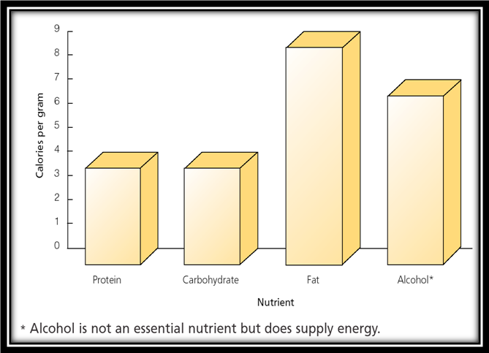

- Proteins—The Basis of Body Structure
- ________________ = a compound made of amino acids that contains _______, _______________, _____________, and ______________.
- Of __________ common ___________in foods, nine are ______________.
- Proteins form key parts of the body’s main ____________ components—______________ and ___________ —and of blood, enzymes, cell membranes, and some hormones

- Complete and Incomplete Proteins
- ______________________________ = foods that supply all the essential amino acids in adequate amounts
- _______________________________________________
- ______________ = foods that supply most but not all essential amino acids
- _______________________________________________

- Recommended Protein Intake
- Adequate daily intake of protein = ___________________(0.36 gram per pound) of body weight
- Acceptable ________________Distribution Range = ________ of total daily calories as protein

- Fats—Essential in Small Amounts
- Fats supply _____________, ____________ the body, support and cushion organs, absorb fat-soluble vitamins, ____________________
- ____________________ (linoleic acid and alpha-linolenic acid) are key regulators of body process such as the ________________________and the progress of a healthy pregnancy

- Types and Sources of Fats
- ________________________ = a fat with no carbon-carbon double bonds; usually solid at room temperature
  - Found primarily in _______________and palm and coconut oils
- _____________________= a fat with one carbon-carbon double bond; usually liquid at room temperature
  - Found in certain vegetables, nuts, and ____________________
- ____________________= a fat with two or more carbon-carbon double bonds; usually liquid at room temperature
  - Found in certain vegetables, nuts, and vegetable oils and in fatty fish
- Two key forms of polyunsaturated fats:
- ___________________ are produced when the endmost double bond of a polyunsaturated fat occurs three carbons from the end of the fatty acid chain
  - Found primarily in ________
- ____________________are produced when the endmost double bond of a polyunsaturated fat occurs six carbons from the end of the fatty acid chain
  - Found primarily in certain ________________ especially corn, soybean, and cottonseed oils

- Total Fat Content of Foods
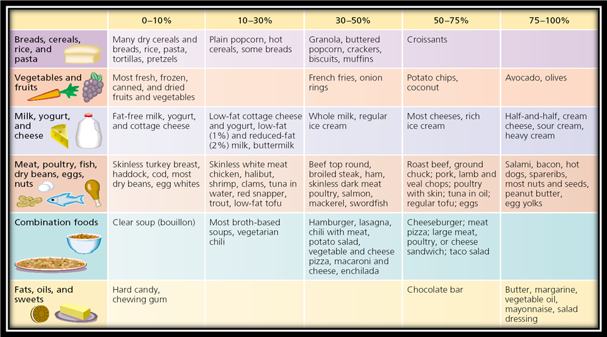

- Fats and Health
- Fats affect blood ____________________
- ___________________ (LDL) = “bad” cholesterol
- ___________________ (HDL) = “good” cholesterol
- ___________________________raise levels of LDL; trans fats also lower levels of HDL
- _____________________ lower levels of LDL
- Fats also affect ________________________________________
___________________________________________________
- Best choices = ____________________ fats and _______________ _______________ fats
- Limit intake of ___________________

- Saturated and Trans Fats: Comparing Butter and Margarine

- Recommended Fat Intake
- Adequate daily intake of fat: = ______________________________
- Acceptable Macronutrient Distribution Range = ___________of total daily calories as fat

- Carbohydrates—An Ideal Source of Energy
- The ____________________ of dietary carbohydrate is to supply _____________ to _____________.
- Some cells, such as those in the _____________, ______________, and ______________, use only _______________for fuel
- During _________________exercise, ______________ get most of their energy from ___________________
- _____________________, carbohydrates are ____________ into single sugar _______________ such as glucose for ______________; the liver and muscles take up glucose and store it in the _______________ __________________

- Simple and Complex Carbohydrates
- _____________________ contain one or two sugar units in each molecule
  - Found naturally in ________________and added to many other foods
  - Include: __________________________________________
- _____________________consist of chains of many sugar molecules
  - Found in plants, especially _______________________________
  - Include: __________________________________________

- Whole Grains
- ________________________, all grains are whole grains consisting of an inner layer of germ, a middle layer called the endosperm, and an outer layer of bran
- ______________________, the germ and bran are often removed, leaving just the starchy endosperm
- Refined carbohydrates usually _______________________________
___________________________________________________

- Refined Carbohydrates Versus Whole Grains
- Whole grains are higher than refined carbohydrates in ________________
___________________________________________________
- _______________________________________
- _______________________________________
- _______________________________________
- Choose foods that have a _______________as the ___________ item on the ingredient list on the ____________
- ____________________________________________________
____________________________________________________

- Recommended Carbohydrate Intake
- Adequate daily intake of carbohydrate = __________
- Acceptable Macronutrient Distribution Range = ___________of total daily calories as carbohydrate
- ___________________________
- Food and Nutrition Board: ________ or less of total daily calories
- World Health Organization: _________ or less of total daily calories

- Acceptable Macronutrient Distribution Ranges: Summary
- ___________ = ___________ of total daily calories
- ___________ = ___________ of total daily calories
- ___________ = ___________ of total daily calories

- Fiber—A Closer Look
- ______________ = nondigestible carbohydrates and lignin that are present naturally in plants
- ______________ = nondigestible carbohydrates isolated from natural sources or synthesized in a lab and added to a food or supplement
- ______________ = dietary fiber + functional fiber

- Sources of Fiber
- All plant foods contain ___________, but processing can remove it
- Good sources of fiber:
  - ______________(especially whole, unpeeled fruits)
  - ______________
  - _______________
  - ____________(especially oat bran)
  - ______________________
  - _________________ (found in some cereals and laxatives)

- Recommended Intake of Fiber
- Women = ___________ per day
- Men = ___________ per day
- Americans currently consume about ________________
- Vitamins—__________________________
- __________ = organic (carbon-containing) substances needed in small amounts to help promote and regulate chemical reactions and processes in body cells.
- Four vitamins are __________________ (A, D, E, and K)
- Nine vitamins are ___________________ (C and the eight B-complex vitamins: thiamin, riboflavin, niacin, vitamin B-6, folate, vitamin B-12, biotin, and pantothenic acid)

- Vitamins
- Vitamins are abundant in_____________________________; they are also added to some processed foods
- If you consume _____________ or _____________ of a particular vitamin, characteristic symptoms of excess or deficiency can develop
- Vitamins commonly lacking in the American diet:
  - Vitamin ____
  - Vitamin ____

  - Vitamin ____
  - Vitamin ____

- Minerals
- If you consume too much or too little of a particular mineral, characteristic symptoms of _____________________________
- Minerals commonly lacking in the American diet:
- Iron = ______________________________
- Calcium = _____________________________
- Potassium = __________________________________________

- Water—A Vital Component
- Human body is composed of about ____________; you can live only a few days without water
- Foods and fluids you consume provide _______ of your daily water intake
- Adequate intake to maintain hydration:
  - __________ need to drink about ____ cups of fluid per day
  - __________ need to drink about ____ cups of fluid per day
  - Drink in response to _______; consume additional fluids for ________

- Should You Take Supplements?
- The Food and Nutrition Board recommends supplements only for certain groups:
  - ___________ for women capable of becoming pregnant (400 µg/day)
  - ___________ for people over age 50 (2.4 mg/day)
- Other possible situations for supplements:
  - Vitamin C for _____________
  - Iron for ________________
  - Vitamin K for _____________
  - People with certain special health cancer

- Canada’s Food Guide
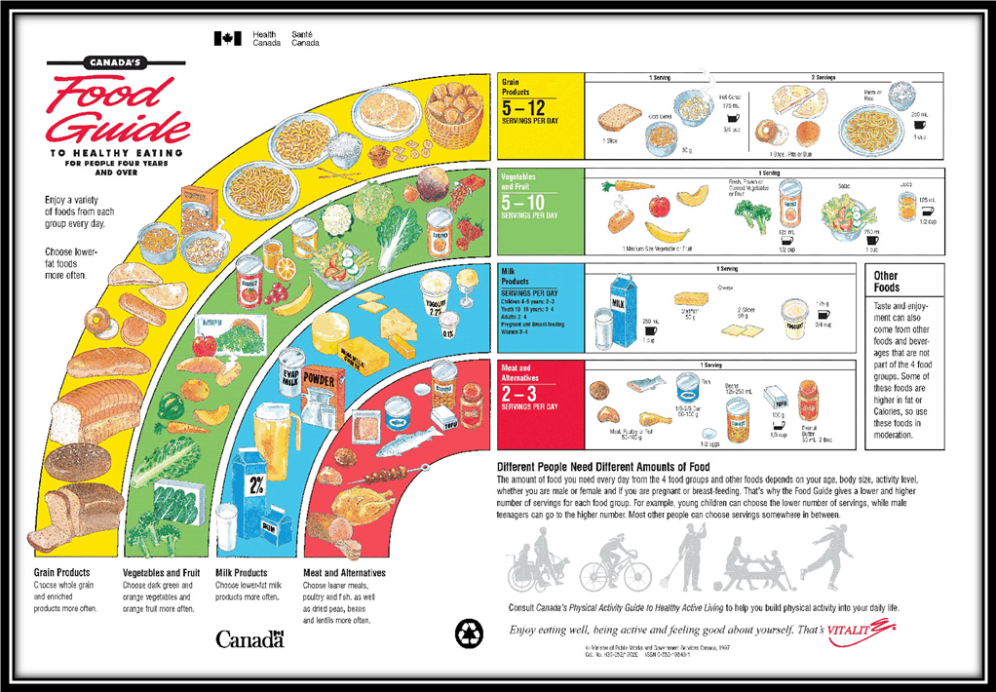
- Food Labels
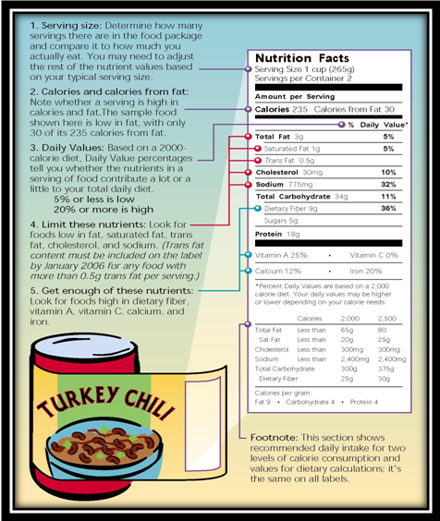
Read labels to learn more about your food choices.
- Dietary Supplements
- May contain _______________________________
- Not _______________ the way drugs are by the _______________ in terms of testing and manufacture
- May interact with_______________ , __________________ and ________________

- Dietary Supplements
