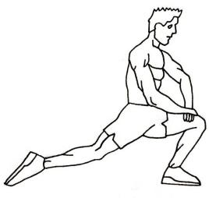
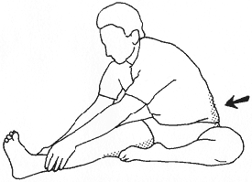
FLEXIBILITY
PART ONE:
Using the slideshow on our course website, answer the following questions.
- What is flexibility? (2 marks)

- List three reasons why flexibility training is important. (3 marks)

- What is the difference between static stretching and dynamic stretching? (4 marks)

- Explain proprioceptive neuromuscular stretching. (2 marks)

- List and explain the guidelines for flexibility training. (5 marks)

PART TWO:
Read the article "Ask the Ripped Dude: Should I Stretch Before My Workout" and choose 3 dynamic stretches. Watch the videos and describe the stretches below. (3 marks each).
- Name of dynamic stretch_____________________
- Muscle(s) involved:

- Description of stretch:

- Name of dynamic stretch_____________________
- Muscle(s) involved:

- Description of stretch:

- Name of dynamic stretch_____________________
- Muscle(s) involved:

- Description of stretch:

PART THREE:
Using the internet, research 5 static stretches that you can use for a cool down. (3 marks each)
- The name of static stretch _________________
  - Muscle(s) involved
  - Description of stretch

- The name of static stretch _________________
  - Muscle(s) involved

  - Description of stretch

- The name of static stretch _________________
  - Muscle(s) involved

  - Description of stretch

- The name of static stretch _________________
  - Muscle(s) involved

  - Description of stretch

- The name of static stretch _________________
  - Muscle(s) involved

  - Description of stretch

