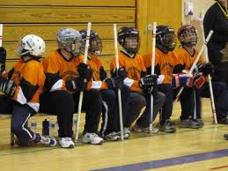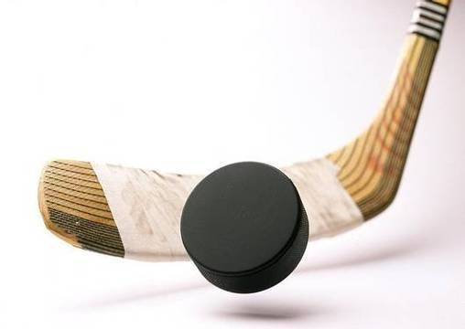images2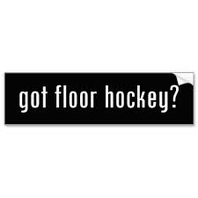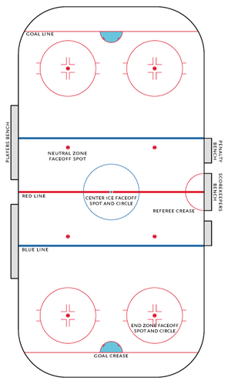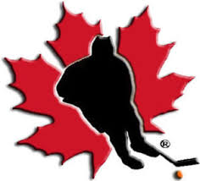s

Basic Strategy:

Work to keep the puck on your offensive end and away from your team’s goal.

Do not play the puck up the middle of the playing surface but use the sides.

Communicate with your teammate by talking.

Use the word “time” to let them know they have some time to look before playing the puck.

Use the word “man on” to let them know they need to play the puck quickly.

* Tom Harder, director of Recreation in Battle Creek, Michigan developed floor hockey in 1962.
* The game is designed for strenuous activity and continuous play.
* The game combines the rules of ice hockey ad basketball with an emphasis placed on playing the puck not the opponent.
* Body checking in forbidden, making it safe and idea activity.

# HISTORY

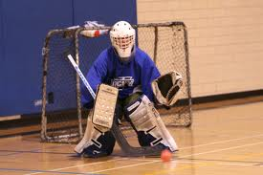

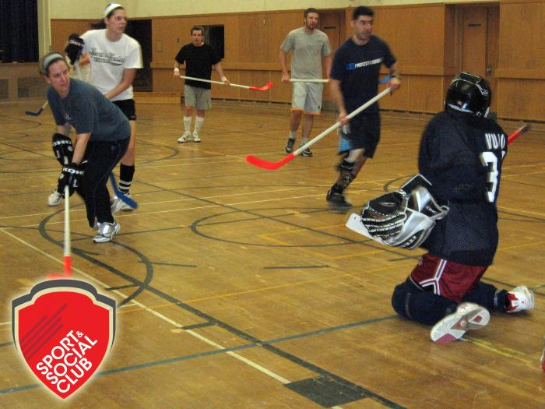

FLOOR HOCKEY

#

If the puck enters the corner and a player has control, a member of the opposite team may attempt to steal the puck but must at all times have 2 hands on their stick.

if a puck slides under the bleachers or other equipment, one team will put the puck back in play with a pass. The defensive player must give them at least 2 meters to play the puck.

Sportsmanship is important in all activities and students are expected to demonstrate good sportsmanship throughout the game.

Scoring:

One point is scored each time the puck passes across the goal line.

Pucks can deflect off of a player of equipment.

Pucks cannot be kicked in the goal.

Penalties: NO

Hacking or striking with the stick.

Pushing or tripping.

Blocking with the body.

Any action considered dangerous to another player.

High sticking above the knees.

Slashing with the stick.

Any time play is deliberately stopped by laying on, stepping on, or holding the puck.

Too many players on the floor.

Offensive or defensive players in the goal box.

** If the opposition scores a goal during the penalty, the player may return to the floor.

Goaltenders:

The goalkeeper msut use his or her stick to clear the puck away from the goal.

The goalkeeper must wear a mask.

It is recommended that the goalkeeper wear a blocker and a glove.

The goalkeeper may not throw the puck toward the other end of the playing area. No other player may enter the goal box without being charged with misconduct. The goalkeeper will be charged with a penalty if he or she hold the puck for more than 5 seconds.

The goalkeeper may be pulled from the goal box, but is restricted to the center line.

Rules:

There are 6 players to a team: a right and left wing person and a center to make up the forward line (offence) and right and left defense person and a goaltender make up the remainder of the team members.

At the beginning of the game a face off occurs. One player from each team will start in the center facing each other, with their stick blades flat on the ground. In a real game, an official drops the puck between the blades and the players try to pass it to a teammate.

In floor hockey, after a goal is scored, the team that was scored on puts the puck into play by passing it from behind their net from a destination spot.

If the goal stops the puck, a member of their team is given the puck behind their net and they must make a pass to a teammate.

Goalies must pass the puck out of the crease using their sticks. Only the goalie may be in the crease. Players are not allowed to enter the crease but their sticks may get a loose puck.