Practice Test
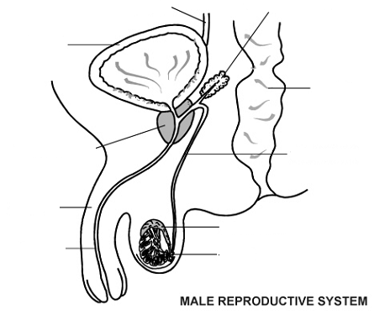
Label the following diagrams.
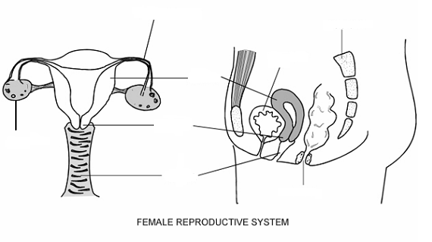
True or False:
- Women start off with 300,000 eggs per ovary.
- The baby grows inside the vagina.
- Ovulation is when the egg is released from the ovary. This occurs on approximately day 20 of the menstrual cycle.
- The urethra is only found in males.
- Urine comes out of the urethra.
- The hymen is a thin tissue inside the vagina.
- A baby grows inside the female for approx. 39-40 weeks.
- The number of sperm in one ejaculation totals approximately 50-200 million.
- When the sperm cell penetrates the egg cell, this is called fertilization.
- It takes many sperm to fertilize one egg.
- Sperm can live outside of the body for up to 5 days. is
- A vasectomy is a procedure In which the foreskin removed from the penis.
- Semen includes both the sperm and seminal fluid.
- Abstinence is the only 100% effective birth control.
- Hormonal methods such as the pill prevent the egg from releasing.
- You must see a health professional to get the Pill.
- Smoking does not increase the risk harmful side effects for the baby and mother while she is pregnant.
- Gonorrhea is the most common STI for people ages 18-24 years of age.
- Chlamydia is a viral STI.
- People with chlamydia always have symptoms.
- If syphilis goes untreated it can cause brain damage, blindness and even death.
- Herpes is a viral STI and can be cured.
- You can transmit HIV by: semen, vaginal fluids, blood and breast milk.
- You cannot contract HIV by hugging someone.
- HPV causes genital warts.

- What are the characteristics of a healthy relationship?
- How do your break-up with someone?
- How can your lower the risk of getting an STI?
- What are the emotional and physical consequences of having sexual intercourse?

