Name: ______________________________________________________ Date: ___________________________________
Ringette Assignment

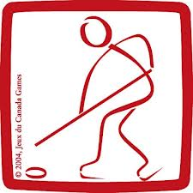
- Answer the following questions in the space below, please put in your own words.

- Who invented Ringette and where was he from? (2 marks)

- What is the blue line violation? (3 Marks)

- List the six positions for Ringette. (6 Marks)

- How does the games start?

- What is the free pass line? (2 Marks)

- What is special about the goalies crease? (2 Marks)

- What is the difference between and minor and major penalty? Give two examples of each. (6 Marks)

- On the backside of this paper draw a diagram and fully label the playing area. (5 Marks)

