Name: ____________________________ Date: _________________
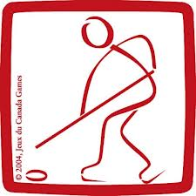
Ringette Rules

Players
Six players per team – five skaters and a goalie – are permitted on the ice at one time. A team plays ‘short-handed’ (‘down’ one or two players) when a player gets a penalty and must spend time in the penalty box. One center, left wing, right wing and two defenseman.
On occasion, a team will ‘pull’ their goalie off the ice and send on an extra skater. If the goalie is pulled and play returns to that team’s defensive end, one skater may become an ‘acting goalkeeper’ (AGK). Once she enters the crease, the acting goalkeeper must play by the same rules as a regular goalkeeper.
Blue lines
Players are not allowed to carry the ring over the blue line. The ring can only cross over the line by a player passing it to a teammate.
Players are not permitted to pass the ring over both blue lines. If this happens, no violation is called unless the same team who passed the ring is the first to touch it. The opposite team must pick up the ring in their end or the play will be whistled.
The goalie can throw the ring over the blue line, but her team cannot touch the ring for five seconds or until the other team gains control.
Free Play Line
The line at the top of the defensive circles is called the Free Play Line, or the Ringette line. Only three players from each team, plus the defending goaltender, are permitted beyond this line. Exceptions to this rule are a) when the defending team has two or more penalties, in which case only two defending players are permitted inside their own defensive zone, and, b) when the offensive team has pulled their goalie, allowing them to send a fourth player into the zone. Violation of the “three-in” rule results in a delayed whistle, whereby the official will stop the play if the offending team gains possession of the ring within five seconds of committing the “four-in” offense.
Crease
The goal crease is a zone in front of the goal mouth where only goalies are permitted. If another player goes into the crease while carrying the ring, play is stopped, and the goalie receives the ring for a goalie ring.
If a defensive team member enters the crease, she cannot touch the ring for five seconds, or possession of the ring is given to the other team. When this happens the defending team still defends, only without being able to touch the ring.
When the ring enters the crease, it is called a “goalie ring”. The goaltender has five seconds to throw, push or pass with the ring to another player. The goalie can pass the ring to a teammate beyond the blue line using the stick. If she passes it beyond the blue line by hand, her team must wait five seconds before touching the ring. If the goalie does not pass it within five seconds, the ring is awarded to the other team for a free pass from one of the free play circles. The goalie may use the stick to touch the ring outside the crease, and can also pass it through the crease but may not pull the ring into the crease. This results in a whistle with a loss of possession and a penalty if she’s already been warned.

Ringette Shot Clock
The team in possession of the ring has 30 seconds to shoot or it loses possession to the other team. The shot clock is reset when:
a) possession of the ring changes teams b) the ring stops in the goaltender’s crease, or c) the ring hits the goalie. The shot clock is only applied in competitive levels.
Minor penalties in Ringette
A minor penalty is called for boarding, charging, cross-checking, elbowing, holding, illegal substitution, hooking, high-sticking, tripping, body contact, slashing, interference, delay of game, and unsportsmanlike conduct.
When a penalty is called, the offending player must sit in the penalty box for two minutes and her team plays short-handed (with four skaters or three if two or more players receive a penalty). If a goal is scored against the short-handed team, one player can return to the ice and the team will no longer be shorthanded. So a team plays with a minimum of three skaters on the ice, regardless of the number of penalties.
A delayed penalty occurs when the team not in control of the ring commits a penalty. Play is not stopped until the penalized team gains control. A minor penalty is nullified if a goal is scored during the delay, unless penalties of equal class were called on both teams.
If freeing a player from the penalty box would give the team more players on the ice than it is entitled to (such as when the team is down to three attackers, but there are two other players in the penalty box), she will not be freed until a whistle stops play. During the stoppage, the team must remove one player from the ice to return to its proper strength.
A team with two penalties can have only two players (instead of the usual three) in its defensive zone. All three players may enter the offensive zone.
Major Penalties in Ringette
Major penalties are assessed for serious offenses such as slashing, charging, body contact or boarding or anytime it the referee deems there is intent to injure.
Major penalties are four minutes in length and last the entire four minutes, even if a goal is scored. Players can receive two penalties at the same time for a combination of four or more minutes, for very serious offenses.
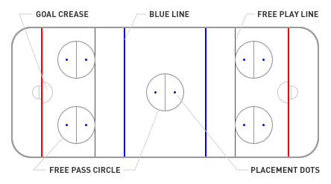
If a misconduct or match penalties is called the offending player is ejected from the game. A substitute player must serve the penalty for the ejected player, but if it’s awarded to a member of the bench staff, the team will not play shorthanded.

