Sports Science

Name: ___________________________________________ Date: ____________________________
Due Date: Wed. April 30th
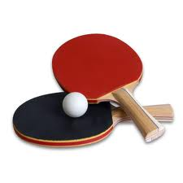

- At what rate of rotational velocity does Erica have
on her serve? ____________________________________.

- It is _______________________________ as fast as a major league fastball.

- Topspin will make the ball move approximately ______________________ feet.

- Ping-pong players rely on their __________________________ for information regarding the spin on the ball.

- Audile stimuli reaches the brain _______________________ seconds faster than visual stimuli.

- How long is the pin pong table? _______________________

- Why do some profession players play up to 20 feet behind the table?

- Endurance for table tennis is comparable to the endurance of professional ___________________________________________.

- Air drag causes a decrease in speed by ___________________________ percent.

