Name: ___________________________________ Date:__________________________
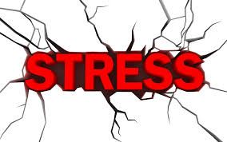

- Watch the video on stress. List 5 “stressors” the teens mention in the video and list 3 ways they cope/deal with stress (8 Marks)

Stressors:

Ways to Cope:

- List your top 3 stressors and 2 ways that you cope/deal with stress. (5 Marks)

Your stressor:

Ways you cope:

- Define stress. (2 Marks)

- Define stressor. (2 Marks)

- Explain in detail how the human body responds to stress. (10 Marks)
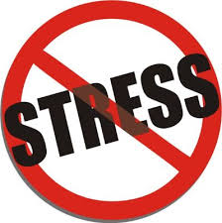

- Explain why the “stress response” of fight or flight is critical in emergencies and also in a pressure situation. (3 Marks)

- Explain in detail how the body copes with long-term stress. (5 Marks)

- Define post-traumatic stress disorder. (2 Marks)

- List 5 signs of stress overload. (5 Marks)

- List 7 things you can do to keep stress under control. (7 Marks)

- List 7 ways you can build your resilience to stressful situations. (7 Marks)

