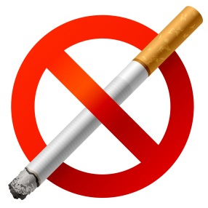

ALCOHOL, TOBACCO, AND DRUGS:
True or False?
Statement | Circle True or False
Drugs are any substance that affects a person’s mental, emotional,  or physical state. | True or False
Hallucinogens can affect vision, hearing, smell, and touch. | True or False
Cannabis (Marijuana) acts as a hallucinogen and as a stimulant, but it does not act as a depressant. | True or False
Nicotine, caffeine, and cocaine are all various forms of stimulants. | True or False
Anabolic steroids, when used to enhance athletic performance and body image, cause no physical or psychological side effects. | True or False
Depressants slow down various body systems and reduce inhibitions. | True or False
Magic mushrooms, LSD, and mescaline are all forms of depressants. | True or False

