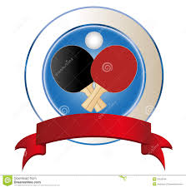
Wikipedia - Table Tennis

Name: ________________________________________________ Date: ___________________________________
Due Date: Wed April 30th

Read the information on the Wikipedia website and answer the following questions on Table Tennis.

- Where and when did the game of table tennis originate?

- Other than a coin toss, how can the start of the game determined?

- List 3 reasons why a “LET” is played the game of table tennis.

- What are the two types of grips and BRIEFLY explain them.

- What are five offensive strokes?

- What are the four defensive strokes?

- What are the four types of spins that can be put on a ball, give a BRIEF description of them.

